**The asymmetric impacts of feeding China’s monogastric livestock with food waste on food security and environment sustainability**

Weitong Long1,2, Xueqin Zhu1*, Hans-Peter Weikard1, Oene Oenema2,3, Yong Hou2*

1Environmental Economics and Natural Resources Group, Wageningen University, Hollandseweg 1, 6706 KN Wageningen, The Netherlands

2State Key Laboratory of Nutrient Use and Management, College of Resources and Environmental Science, China Agricultural University, 100193 Beijing, China

3Wageningen Environmental Research, 6708 PB Wageningen, The Netherlands

⁎ Corresponding author at: Wageningen University, 6706 KN Wageningen, The Netherlands; China Agricultural University, 100193, Beijing, China.

E-mail addresses: [xueqin.zhu@wur.nl](mailto:xueqin.zhu@wur.nl) (X. Zhu); [yonghou@cau.edu.cn](mailto:yonghou@cau.edu.cn) (Y. Hou).

# Abstract

Around 1.3 billion tonnes of food waste are produced in the world, which are mainly disposed in landfills and incinerators, and are a significant source of greenhouse gas (GHG) emissions. While feeding animals with food waste may decrease such emissions, potential "rebound effect" remain unexplored. We used an integrated environmental-economic modelling framework to assess the impacts of upcycling food waste in China’s monogastric livestock production in a global context. We found that upcycling 54-100% of food waste as feed increased monogastric livestock production (25-37%) and average wage across the Chinese economy (0.18-0.22%), with negative indirect effects such as increased total agricultural land use (0.5-0.6%) and economy-wide emissions of acidification (3-6%) and eutrophication (0.5-0.8%) pollutants in China. Synergy effects from less food waste in landfills and incinerators, along with the contraction in non-food production, decreased Chinese economy-wide GHG emissions (0.5-0.9%). While feeding food waste strategies enhanced food availability (6-12 kcal capita-1 day-1) and affordability (0.38-0.49%) in China, it slightly reduced food availability (0.5-1.0 kcal capita-1 day-1) and increased affordability (0.18-0.22%) in its trading partners. Our results highlight the asymmetric impacts of feeding China’s monogastric livestock with food waste on food security and environment sustainability, urging complementary measures and policies to mitigate negative spillovers when promoting more circular food systems.

# Keywords

circular economy; food waste; food security; environmental sustainability; environmental-economic modelling; rebound effects.

# Main

The surge in demand for animal-sourced food (ASF) such as meat, milk, and eggs is driven by population growth, prosperity, and urbanisation 1,2. The global demand for ASF is projected to double by 2050; the increase will occur, particularly in developing countries 3. Livestock production expansion has driven global demand for animal feed as well as land used for feed crops, intensifying the food-feed competition and causing serious environmental concerns. Currently, 70% of global agricultural land is used for producing animal feed 4, and global livestock production account for 13-18% of the total anthropogenic greenhouse gas (GHG) emissions 5, 40% of the ammonia (NH3) and nitrous oxide (N2O) emissions 6, and around 24% of nitrogen (N) and 55% of phosphorus (P) losses to water bodies 7.

Globally, approximately 1.3 billion tons of food (roughly one-third of the total amount of food produced for human consumption) are lost or wasted each year, a considerable portion of which is disposed in landfills or incinerators, further exacerbating GHG emissions and climate change 8. Upcycling food waste to substitute human-edible feed crops in animal diets may decrease GHG emissions associated with landfill and incineration and is crucial for building circular food systems 9. Further, low-opportunity-cost feed (LCF), i.e., food waste and food processing by-products, typically compete less for land and natural resources than cereals and oilseeds, which are the main compounds of concentrated feed for monogastric livestock 9-11. Feeding animals with food waste offers a pathway to mitigate land-related pressures 10, alleviate the food-feed competition 9, and reduce emissions from improper food waste disposal 11. Increased utilisation of food waste as feed may also contribute to achieving Sustainable Development Goals (SDGs), including SDG 2 (zero hunger), SDG 6 (clean water and sanitation), SDG 12 (responsible consumption and production), SDG 13 (climate action), and SDG 15 (life on land) 12.

Building more circular food systems through increased utilisation of food waste as feed may also result in indirect effects and spillovers, which have not yet been investigated. First, feeding animals with food waste may lower feed costs and boost farm profits, which may drive livestock production expansion and lead to increased emissions—a phenomenon known as the "rebound effect" or “Jevons paradox” 13. Second, increased utilisation of food waste as feed will not only impact consumers and producers of livestock but also have knock-on effects on other commodities in the broader economy. For instance, heightened demand for feed due to expanded monogastric livestock production may drive up crop production, leading to increased demand for land, fertilisers, and associated emissions. In addition, less food waste in landfills and incinerators may contribute to lower GHG emissions. Reducing cropland areas and GHG emissions are seen as the two key environmental benefits of feeding animals with food waste 9-11. However, the possible rebound effect of expanded livestock production and its knock-on effects on other commodities could alter the expected outcome in terms of reducing agricultural land use and emissions. In essence, while previous studies 9-11 acknowledge the environmental benefits of increasing food waste utilisation as feed, their employment of linear optimisation models may overestimate the environmental benefits by disregarding market-mediated responses via the price system (i.e., holding costs and prices constant). Third, the food price may change, which could influence the availability and access dimensions of food security 14. For example, the increased food production will enhance food availability, leading to lower food prices, but the expanded livestock production will stimulate labour demand, thus raising the economy-wide average wage. Food affordability is determined by fluctuations in the prices of a food consumption basket relative to changes in consumer income 15. However, solely focusing on food price fluctuations without considering income changes resulting from increased food waste utilisation as feed may lead to biased conclusions on changes in food affordability.

Applied general equilibrium (AGE) models based on microeconomic theory are useful tools for analysing the economy-wide effects (i.e., production, consumption, and trade) of a transition to a circular economy 16,17. AGE models can depict sectoral interactions, international trade, and consumer responses to changing prices and incomes, making them valuable tools for assessing the consequences of the transition towards more circular food systems. However, this requires that monetary AGE models do fully account for biophysical (quantity-based) and nutritional (protein and energy-based) livestock feeding constraints, which are crucial for analysing the environmental and economic impacts of feeding animals with food waste. Although previous studies 18-21 have endeavoured to integrate biophysical and nutritional livestock feeding constraints into AGE models, none have yet explored the potential impacts of upcycling discarded food waste as animal feed. Moreover, AGE models such as GTAP-E 22, GTAP-AEZ 23, GTAP-BIO 24, and MAGNET 25 primarily focus on GHG emissions and overlook other pollutants. It is crucial to encompass not only GHG emissions but also pollutants leading to acidification (i.e., NH3 emissions to air) and eutrophication (i.e., N and P losses to water bodies) from livestock production within the AGE framework, given that livestock contributes more to these pollutants than to GHG 26-29. Yet, no studies have done that so far.

In this study, we analysed the possible environmental and economic consequences of upcycling food waste in China’s monogastric livestock production in a global context. China is the world’s largest animal producer, and accounted for 46%, 34%, and 13% of the global pork, egg, and poultry meat production in 2018, respectively 30, making it a focal point of our study. We address three main research questions, emphasising indirect effects and spillovers not directly covered in previous studies. First, how will an increased utilisation of food waste as feed influence livestock production, food supply, and other sectors in China? Second, how will these influence GHG emissions and the pollutants emissions leading to acidification and eutrophication? Third, how will an increased utilisation of food waste as feed influence food availability and food affordability, which are crucial indicators of food security, if we account for changes in food prices and wages that provide the main source of consumer income? The novelty of this study lies in the improvement of an integrated environmental-economic framework by bridging monetary AGE models with biophysical (quantity-based) and nutritional (protein and energy-based) constraints. This improved framework may capture the rebound effect of expanded livestock production, its knock-on effects on other commodities, and the changes in food prices and consumer income when promoting circular food systems through increased utilisation of food waste as feed. Furthermore, integrating emissions of GHG and pollutants that lead to acidification and eutrophication into the AGE framework simultaneously allows us to discern the trade-offs and synergies associated with each type of emission.

We examined two scenarios with changed animal diets and compared these scenarios to a baseline (S0) scenario for the year 2014 without changing animal diets. Scenario S1 investigated the environmental and economic impacts of allowing partial use of food waste as feed (54% of food waste and 100% of food processing by-product waste) for monogastric livestock. Scenario S2 analysed the environmental and economic impacts of allowing full use of food waste as feed, taking into account economies of scale. In S1, cross-provincial transportation of food waste with high moisture content was not allowed, which limits the maximum utilisation rate of food waste to 54% in China, according to Fang, et al. 10, whereas it was allowed in S2. Economies of scale in food waste recycling were considered in S2; a 1% increase in recycled waste resulted in only a 0.078% rise in recycling costs, as reported by Cialani and Mortazavi 31. The inclusion of two food waste-related sectors (see Fig. 1 and Methods) in the enhanced framework makes it capable of exploring the potential reuse of discarded food waste as animal feed. These sectors include the food waste recycling service sector for recycling food waste as animal feed and the food waste collection service sector for collecting food waste for landfill or incineration. The consumer price of food includes both the market price of food and the cost of collecting food waste by the municipality. In terms of recycling food waste as feed, monogastric livestock production bears the associated cost. When substituting primary feed (i.e., crops and compound feed) in animal diets with food waste, we maintain the protein and energy supply per unit of animal output in all scenarios to prevent imbalances between nutritional (protein and energy) supply and livestock requirements. The scenarios mentioned above are further described in Table 1.

# Results

# Impacts on livestock production, food supply, and other sectors.

China produced about 103 Tg of monogastric livestock products (pork: 57 Tg; poultry: 18 Tg; egg: 29 Tg) in 2014. The food recycling service sector recycled only 39% of food waste and 51% of by-product waste as feed (see Table 1). Expanding this sector to accomplish the goal of upcycling 54-100% of food waste as feed provided 18-28% more feed protein and 22-69% more feed energy for monogastric livestock production compared to current feed sources. This led to a 3.4-4.1% reduction in feed costs for per animal output, boosting profits for monogastric livestock producers and driving a 25-37% expansion in production (Fig. 2a). This shift also signals a transition for China from a net importer of monogastric livestock (with 1.1% of output imported in our baseline scenario S0) to an exporting nation of monogastric livestock (with 24-35% of output exported) (Fig. 3e). Increased shares of food waste use (9-14% in dry matter, 4-6% in protein, and 8-12% in energy; see Supplementary Fig. 1) within total feed use led to an equivalent decrease in demand for primary feed (i.e., crops and compound feed) for per unit of monogastric livestock production.

To quantify the contribution of human–edible feedstuffs to the animal-based food supply, we defined the eFCR (edible Feed Conversion Ratio) 32 as the quantity of human–edible feedstuffs included in the total feed to produce one unit of live weight gain of livestock production. Increased utilisation of food waste as feed alters FCR (feed conversion ratio, a ratio between the fresh matter of feed inputs and the live weight gain of livestock production) and eFCR. Despite a moderate increase in FCR (0.16-0.56 kg·kg-1) for monogastric livestock, the decreased eFCR (0.14-0.23 kg·kg-1) demonstrates reduced utilisation of human-edible feed crops for per unit of monogastric livestock production (Fig. 2b). However, the total demand of human-edible feed crops in monogastric livestock production increased by 9.5-9.9% (see Supplementary Fig. 2) due to expanded monogastric livestock production, intensifying demand for cropland by 0.4-0.6% (Fig. 2c). Negligible changes (less than 0.001 kg·kg-1) were observed in FCR and eFCR in ruminant livestock production due to minute changes in the production and feed use of ruminant livestock.

Feeding food waste strategies increased demand for feed crops and compound feed, driven by expanded monogastric livestock production, leading to a 0.18-0.22% rise in the average wage across the Chinese economy (see Supplementary Fig. 3), given that the crop and livestock sectors comprise 19% of the total labor supply. Consequently, labour became relatively more expensive compared to other factor inputs such as capital, cropland, and pasture land (see Supplementary Fig. 3). Consequently, producers will substitute labour with these relatively cheaper factor inputs. Ruminant livestock production remained nearly static, with the rise in labor costs offset by a corresponding increase in pasture land usage, driving a 0.5-0.7% increase in demand for pasture land (Fig. 2c). Crop producers will prioritise reducing the production of relatively labour-intensive crops; for example, roots & tubers are expected to decrease by 7-90% and sugar crops by 17-27% (Fig. 2c,d). The cropland saved from the reduced production of relatively labour-intensive crops will be reallocated to increase the production of crops that require relative more cropland or capital, such as cereal grains (1-3%), vegetables & fruits (2-3%), and other non-food crops (34-105%) (Fig. 2c,d). The larger percentage changes in other non-food crop production, compared to cereal grains and vegetables & fruits, can be attributed to initially low share acreage in total cropland occupation, accounting for less than 0.5% (see Supplementary Fig. 4). Notably, the production of oilseeds & pulses decreased by 8% when partial use of food waste as feed was allowed but increased by 71% when full use was allowed (Fig. 2c,d). This phenomenon arises because oilseeds & pulses are not only relatively cropland-intensive but also labour-intensive crops compared with other crops so the changes in their production depend on the interplay between labour and cropland costs under different scenarios.

Changes in crop production will alter their self-sufficiency ratios (SSRs, a ratio between domestic production and domestic utilisation). We found that the SSRs of roots & tubers and sugar crops decreased by 8-90% and 17-27%, respectively (Fig. 3e). The SSR of oilseeds & pulses increased by 26% when full use of food waste as feed was allowed, but decreased by 4% when allowing a partial use of food waste as feed (Fig. 3e). When full use of food waste as feed was allowed, the imports of cereal grains and other non-food crops decreased by 1.5 and 1.2 times of the initial levels, which led to complete self-sufficiency for these crops (see Supplementary Fig. 5).

Despite the 1-4% decrease in total crop production (Fig. 3a), the total fertiliser demand increased by 2-6% (Fig. 3c,d) because of changes in fertiliser demand by the crop type pattern (see Supplementary Fig. 4). Since fertiliser sectors are relatively energy-intensive, fertiliser producers could obtain profits by substituting labour with comparatively cheaper energy (mainly coal). This shift resulted in a 38-40% increase in nitrogen fertiliser production and a 24-64% increase in phosphorus fertiliser production. Consequently, China shifts from a net importer of nitrogen (with 3% of output imported in S0) and phosphorus (with 2% of output imported in S0) fertilisers to an exporting nation of nitrogen (with 27-31% of output exported) and phosphorus (with 20-52% of output exported) fertilisers (Fig. 3f). The significant changes in fertiliser production can be attributed to its initially low share of value-added in gross domestic product (GDP), accounting for less than 0.5% (see Supplementary Fig. 6). From the whole-economy perspective, upcycling food waste in monogastric livestock production as feed prompts a shift of workers from non-agricultural sectors to agricultural-related sectors, leading to an expansion in agricultural production and a contraction in non-agricultural production except for fertiliser sectors (Fig. A6).

# Impacts on emissions.

Changes in production structure will lead to alterations in emissions of GHG (measured by CO2-eq), acidification (measured by NH3-eq), and eutrophication pollutants (measured by N-eq). Our findings revealed trade-offs between reductions in GHG emissions and an increase in emissions of acidification and eutrophication pollutants in China. Upcycling 54-100% of food waste as feed increased economy-wide emissions of acidification (3-6%) and eutrophication (0.5-0.8%) pollutants (Fig. 4b,c) in China, primarily due to the expansion of monogastric livestock production with relatively high emission intensities of these pollutants. The economy-wide GHG emissions decreased by 0.5-0.9% in China (Fig. 4a), despite the rise in GHG emissions from expanded livestock and fertiliser production, indicating synergy effects from less food waste in landfills and incinerators, alongside the contraction in non-food production.

Increased utilisation of food waste as feed will reduce China's reliance on imports of livestock products and fertilisers, resulting in its transition from a net importer to an exporting nation of these commodities (Fig. 3e,f). Consequently, China's main food and feed trading partners (MTP, including Brazil, the United States, and Canada) will experience environmental benefits, including reduced emissions of GHG (1.2-1.5%), acidification (9-14%), and eutrophication pollutants (3-4%). These environmental benefits for MTP stem from saving their domestic production of livestock and fertiliser because China transitions from a net importer of these commodities to an exporting nation of these commodities.

# Impacts on food security and household welfare.

Subsequently, changes in production and prices may also influence not only food supply but also household welfare. We evaluated the availability and access dimensions of food security using food availability (daily per capita dietary calorie availability) and food access (per capita affordability and the average price of the current diet) as indicators. The composition of the current diet was outlined in Supplementary Fig. 7. Since prices offer only partial insight into food affordability, we used changes in the average price of a food consumption basket (current diet) in relation to the economy-wide average wage that provides the main source of consumer income (see Supplementary Fig. 8), as a proxy for food affordability.

Our findings indicated that upcycling 54-100% of food waste as feed slightly increased food availability (0.19-0.37%) and food affordability (0.38-0.49%) in China, which was related to lower food prices (0.20-0.27%) and higher average wage across the Chinese economy (0.18-0.22%) (Fig. 5a,b; Fig. A9). The increased food availability (0.19-0.37%, 6-12 kcal capita-1 day-1) in China could sustain an additional 2.6-5.2 million people (Table A6). Concomitantly, there was a marginal decrease in food availability (0.02-0.03%, 0.5-1.0 kcal capita-1 day-1) in MTP (Table A6). Overall, this initiative could potentially feed 2.5-5.0 million more people in China and MTP together. The increased food affordability in China aligned with a drop in the average price of the current diet (0.20-0.27%) and an increased average wage (0.18-0.22%) (Fig. A9). While food affordability rose for MTP (0.19-0.21%), the increase was smaller than for China (0.38-0.49%) (see Supplementary Fig. 9). Further, household welfare (a measure of economic well-being in million $) increased by 0.19-0.38% in China but decreased by 0.01-0.03% in MTP (see Supplementary Fig. 9). More detailed results on changes in prices by sectors are provided in Supplementary Fig. 10.

# Discussion

This study uses an integrated environmental-economic framework to evaluate the possible environmental and economic consequences of upcycling food waste in China’s monogastric livestock production in a global context. The novelty of this study lies in incorporating biophysical (quantity-based) and nutritional (protein and energy-based) constraints into monetary AGE models, thereby addressing a key limitation of current AGE models 19,21. Feeding monogastric livestock with food waste will induce price changes and have knock-on effects on other commodities in the broader economy, potentially impacting changes in wage, land rent, and rental price of capital. Our approach complements previous linear optimisation studies 9-11, which overlooked market-mediated responses via the price system by considering both direct and indirect (price-induced) effects of increased utilisation of food waste as feed. Our results, thus, enhance the understanding of synergies and trade-offs between economic impacts and multiple environmental stresses associated with the increased utilisation of food waste as animal feed while respecting biophysical and nutritional constraints on livestock production.

Feeding monogastric livestock with food waste contributes significantly to the transition from linear to more circular food systems and alleviates food-feed competition. We found that upcycling 54-100% of food waste in monogastric livestock production significantly increased the shares of food waste use (9-14% in dry matter, 4-6% in protein, and 8-12% in energy) within total feed use for per unit of monogastric livestock production in China, which is crucial for the transition towards circular food systems. Despite a moderate increase in FCR (0.16-0.56 kg·kg-1) for monogastric livestock, the decreased eFCR (0.14-0.23 kg·kg-1) indicates reduced utilisation of human-edible feed crops for per unit of monogastric livestock production. These findings of changes in FCR and eFCR align with findings from Fang, et al. 10 and Gatto, et al. 19.

Feeding waste strategies can also address China's dependence on imported feed. While the 95% SSR redlines were maintained for main staple crops (wheat, rice, and maize), China became increasingly reliant on the imports of soybean, with 66% of the global soy trade purchased by China in 2017 to meet 90% of domestic demand 33. This reliance on external sources presents food security risks 34, which are becoming an increasingly pressing global concern. We found that allowing the full utilisation of food waste as feed reduced cereal grain imports to 1.5 times their initial levels, achieving complete self-sufficiency, while oilseeds & pulses imports decreased by 26%, consistent with expectations outlined by Fang, et al. 10. The decrease in imports of oilseeds & pulses can also reduce the environmental pressure associated with deforestation in Brazil, as 59% of Brazil’s soybean exports associated with deforestation are attributed to China 35. Feeding food waste strategies additionally reduced the economy-wide GHG emissions decreased by 0.5-0.9% in China due to less food waste in landfills and incinerators as well as the contraction in non-food production. This supports China's commitment to achieving carbon neutrality by 2060 36.

While our study confirms the benefits of feeding food waste strategies observed in other studies, we also uncover some indirect and spillover effects associated with increased food waste utilisation as feed, aspects overlooked in prior linear optimisation studies 9-11,37. In contrast to previous linear optimisation studies that assume livestock production remains unchanged as long as feed protein and energy are maintained, our modelling framework enables us to capture the indirect "rebound effect" of expanded livestock production induced by lower feed costs. The rebound effect of increased livestock production and its knock-on effects on other commodities cannot be overlooked, as these potential trade-offs and negative spillovers may alter the expected outcome in terms of reducing agricultural land use and emissions when transitioning to more circular food systems.

The first possible economic spillover effect is a 25-37% expansion of monogastric livestock production in China. This surge is attributed to the provision of 18-28% more feed protein and 22-69% more feed energy for monogastric livestock production through upcycling 54-100% of food waste as feed. Consequently, reduced feed costs and amplified profits for livestock producers incentivise livestock expansion. The expanded livestock production has been confirmed by Tong, et al. 38, who argue that allowing full use of food waste as feed could increase pork production by 14-29% even when holding costs and prices constant. This shift also signifies China's transition from a net importer of monogastric livestock (with 1.1% of output imported in our baseline scenario S0) to an exporting nation of monogastric livestock (with 24-35% of output exported). It is in line with the target of the " 95% SSR target for pork" proposed in 2020 39 to restore the domestic supply capacity under the outbreak of African swine fever 40,41. The expansion of monogastric livestock production, coupled with increased demand for feed crops and compound feed, drove up labour demand, generating a second positive spillover in the average wage across the Chinese economy (0.18-0.22%). Consequently, there was a shift toward substituting labour with other relatively cheaper factor inputs, such as capital, cropland, and pasture land, to choose the cheapest combination of inputs. This generates a third negative spillover effect of expanded monogastric livestock production: heightened agricultural land (cropland and pasture land) demand. In spite of reduced reliance on human-edible feed crops for per unit of monogastric livestock production, our model results indicate that the total demand for human-edible feed crops in livestock production will increase by 9.5-9.9%, intensifying demand for cropland by 0.4-0.6%. Meanwhile, the rise in labor costs also stimulate the use of pasture land for ruminant livestock production, driving a 0.5-0.7% increase in demand for pasture land. Crop producers will prioritise reducing the production of relatively labour-intensive crops (i.e., roots & tubers: 7-90%; sugar crops: 17-27%) and increasing the production of relatively cropland-intensive or capital-intensive crops (cereal grains: 1-3%; vegetables & fruits: 2-3%; other non-food crops: 34-105%). The production of oilseeds & pulses exhibits intriguing dynamics: its production decreased by 8% when partial use of food waste as feed was allowed but increased by 71% when full use was allowed. This phenomenon arises because oilseeds & pulses are not only relatively cropland-intensive but also labour-intensive crops. When partial use of food waste as feed is allowed, the increased cost of labour outweighs the decreased cost of cropland, resulting in reduced production. Conversely, when full use of food waste as feed is allowed, the futher reduced cost of cropland outweighs the increased cost of labour, leading to increased production. Labour, however, can also be substituted by comparatively cheaper energy (mainly coal) for fertiliser production, attributed to the energy-intensive nature of fertiliser sectors. This shift led to a 38-40% increase in nitrogen fertiliser production and a 24-64% increase in phosphorus fertiliser production. This also generates another negative environmental spillover effect by increasing GHG emissions related to fertiliser production. Our results are confirmed by Gatto, et al. 19 who have assessed the impact of subsidising the upcycling of agricultural residues and by-products as feed, revealing increases in agricultural wage, livestock production, and agricultural land use.

Economic spillovers into monogastric livestock sector also unexpectedly reverses the expected outcome in terms of reducing emissions. Our results indicated that feeding food waste strategies increased economy-wide emissions of pollutants associated with acidification (3-6%) and eutrophication (0.5-0.8%) in China, primarily driven by the expansion of monogastric livestock production. In spite of increased GHG emissions from expanded livestock and fertiliser production, China's economy-wide GHG emissions declined by 0.5-0.9% due to less food waste in landfills and incinerators as well as the contraction in non-food production. The positive contribution to lower GHG emissions through interactions with non-agricultural sectors also illustrates the relevance of using an general equilibrium model rather than an agricultural partial equilibrium model. The GHG-related environmental benefits of the increased food waste as animal feed are acknowledged by prior linear optimisation studies 9-11,37; however, in our economy-wide perspective, the primary reduction in GHG emissions stems from less food waste in landfills and incinerators. Due to differing scenario setups and objectives, the results of the linear optimisation studies, as argued by Gatto, et al. 19, are largely incomparable to those in our economy-wide models. Linear optimisation studies often explore extreme scenarios by holding costs and prices constant, contrast sharply with our economy-wide models, which accounts for market-mediated responses via the price system and rational economic behavior of agents to closely mirror real-world conditions. This disparity presents challenges in replicating such scenarios within our economy-wide models, as the monetary constraints and rational economic behaviors modeled in our analysis diverge from the extreme scenarios exclusively detectable in linear optimisation models. Yet, these two modelling approaches could complement each other and support researchers and decision-makers by offering diverse perspectives on the same issue. Prior linear optimization studies could benefit from insights into the potential rebound effects uncovered by our economy-wide models, which potentially diminish the anticipated environmental benefits of feeding food waste strategies. Conversely, economy-wide models could gain valuable insights into envisioning a sustainable future by examining scenarios that disregard market-mediated responses via the price system.

Social spillover effects on food availability and affordability varies across China and its main food and feed trading partners. Some studies 42,43 evaluated food affordability primarily by considering changes in prices without accounting for income fluctuations, which may alter conclusions on changing food affordability. Since prices offer only partial insight into food affordability, we use changes in the average price of a food consumption basket (current diet) in relation to the average wage as a proxy for food affordability. We found increased food affordability in China (0.38-0.49%) aligned with a drop in the average price of the current diet (0.20-0.27%) and an increased average wage (0.18-0.22%), with a smaller increase in food affordability observed for MTP (0.19-0.21%) compared to China. Increased food availability in China could sustain 2.6-5.2 million more people, while a slight decrease in availability among trading partners risks hunger for 0.1-0.2 million people. Nonetheless, global food availability is improved, as China's increase exceeds the decline in its trading partners. This suggests that increased feeding of food waste to pigs in China has impacts that extend beyond borders, a type of telecoupled impact. 44,45

Our findings unveiled the asymmetric impacts of feeding China’s monogastric livestock with food waste on food security and environment sustainability. The concurrent reduction in GHG emissions, coupled with the enhancements in food availability and affordability, underscores the rationale for policymakers to promote the adoption of feeding food waste strategies. This aligns with China's recent emphasis on carbon neutrality and food security as leading priorities 46,47. Despite these benefits of increased utilisation of food waste as feed, policymakers should remain vigilant regarding indirect effects and spillovers, particularly the unintended increases in agricultural land use and emissions of acidification and eutrophication pollutants, and be prepared to implement complementary measures and policies to mitigate these negative effects. Therefore, our findings hold following policy implications.

First, on the one hand, implementing economy-wide taxes on emissions of acidification and eutrophication pollutants alongside feeding food waste strategies could help mitigate the rebound effect of expanded monogastric livestock production, thus alleviating pressures on agricultural land use and reducing these emissions. This approach aligns with the recommendation of Gatto, et al. 20, who proposed using economy-wide GHG taxes to address the rebound effect of non-food sectors with increased GHG emissions during the global EAT-Lancet diet transition. The Chinese government has enacted several environmental policies aimed at reducing emissions of pollutants linked to acidification and eutrophication from agriculture and improving water quality. These policies include (i) Improvement of manure recycling 48, and (ii) Prevention and Treatment of Water Pollution (“Ten-Point Water Plan”) 49. On the other hand, adopting nitrogen mitigation measures for livestock manure could also alleviate the rebound effect of expanded production of monogastric livestock, given that poorly managed livestock manure is identified as the primary source of pollutants associated with acidification and eutrophication in China 50. The estimated rate of manure nitrogen recycling to the field in China, accounting for 32% of total nitrogen excretion 50, significantly lags behind figures reported in the United States (75% ) 51 and European Union (EU) countries (80%) 52. Covering slurry stores and implementing low-NH3 emission manure applications have been embraced by over 90% of farmers in the Netherlands and Denmark 53. However, surveys conducted in China indicate that less than 20% of pig farms have adopted these measures. Policy instruments such as tax incentives and financial grants could accelerate the adoption of these technologies in China to mitigate the unintended increases in emissions of acidification and eutrophication pollutants. Despite the decrease in Chinese economy-wide GHG emissions, it is worth noting that the GHG environmental benefits do not originate from feed crop production but rather from the less food waste in landfills and incinerators. Therefore, China could achieve greater GHG environmental benefits through intensive crop production 54 and the adoption of improved fertilizer production technologies 55. These measures are also consistent with the implementation of the "zero fertilizer growth" policy 56 in 2015 to reduce fertiliser use.

Second, we dodge the question of the policy instruments used to achieve the goal of increased utilisation of food waste as feed by exogenously raising the cost of recycling food waste as feed and lowering the cost of collecting food waste for landfill and incineration. This exogenous shift is similar to key publications on feeding food waste strategies 9-11,37. We assume that the “food waste recycling service” sector exogenously expands its production to achieve the goal of increased utilisation of food waste as feed, leading to an equivalent decrease in the production of the “food waste collection service” sector. This implies that the capital and labour markets for food waste are not included in our analysis. This seems acceptable as the shares of value-added related to food waste in China’s total GDP amount to less than 0.5% (see Supplementary Fig. 6). Achieving close to the full use of food waste as feed seems possible in China because the food waste treatment industry (i.e., food waste collection service and food waste recycling service) is well developed and expanding recently 57. The current reinforced policies on municipal solid waste separation and collection 58 in China guarantee a stable feed supply for monogastric livestock production. Additionally, the geographic proximity of industrial livestock farms to municipal food waste collection plants further facilitates the success of upcyling food waste as feed for monogastric livestock production 57. However, allowing full use of food waste as feed necessitates various investments and policies to support the construction of municipal food waste collection plants to efficiently collet, sanitize, and package food waste for sale to livestock producers as feed 10. In addition, to gain acceptance and adoption among livestock producers, food waste protein production must demonstrate its economic competitiveness against conventional feed proteins such as cereals and oilseeds. Our results demonstrated that upcycling 54-100% of food waste as feed increased feed protein supply by 18-28% and feed energy supply by 22-69% for monogastric livestock production, leading to a 3.4-4.1% reduction in feed costs for per animal output.

Third, our study assumes that individuals employed in non-agricultural sectors can shift to agricultural-related sectors under a constant total labor supply within the economy, following the default settings of standard GTAP 59 and USAGE 60 models. However, constraints on labour mobility, especially in the short term, may exist. On one hand, policies should facilitate the transition of workers towards agricultural sectors by lowering barriers to agricultural jobs through specialized training and educational programs, which could provide workers with enhanced opportunities to consider alternative employment paths. On the other hand, the current agricultural and non-agricultural production in China 61 implies that such shifts may require individuals employed in non-agricultural sectors to relocate from major non-agricultural production regions (i.e., southern China) to regions specialising in agricultural production (i.e., northern China). These relocations could incur tangible costs, which are likely to impact disadvantaged individuals and communities disproportionately.

Despite the integrated and holistic approach, this study has some limitations that necessitate some follow-up. First, our study assumes free international trade, full mobility of factor endowments (capital, labour, and land) across sectors, and constant income elasticities for all consumption goods. Neglecting trade barriers in our analysis may overestimate the extent of international trade of feed and food. Barriers to the movement of factor endowments across sectors could be included, for example, by introducing separate labour and capital markets for agricultural and non-agricultural sectors or allowing for land shifts within agroecological zones with similar soil, landform, and climatic features, as included in the MAGNET 25 and GTAP-AEZ 23 models. Second, expanding our modelling framework to include additional feed types like maize silage, alfalfa hay, and roughage-like by-products would improve the assessment of nutritional balances, particularly in the context of ruminant livestock production. While the estimated FCRs for the monogastric livestock sector closely align with reference estimates observed in literature 10,11,37, our estimates for ruminant livestock are somewhat lower compared to the literature. However, as these feeds are primarily used for ruminant livestock, which is not our main focus, this falls outside the scope of our study. Third, our analysis concentrates on scenarios outlining technically and physically possible options and does not endeavor to depict policy instruments for achieving the goal of increased utilisation of food waste as feed, aligning with key literature on feeding food waste strategies 9-11,37. Crucial questions remain how to design and implement policies that can achieve the goal of increased utilisation of food waste as feed, which falls outside the scope of this study but should be a pivotal direction for future research. Fourth, in line with SDG 12.3 ("halving food waste") 12, high priority should be placed on reducing food waste. With less food waste available for animal feed, the impacts of increased utilisation of food waste as feed may diminish. However, we consider our estimates of the impacts of increased utilisation of food waste as feed as conservative, as we did not factor in cross-provincial transportation of food waste with high moisture content (except in scenario S2). Last but not least, we stress that the model simplifies the real world and draws conclusions from a static model with aggregated goods under current economic conditions. The outbreak of African swine fever in China is not considered in our model, which may overestimate the capacity to feed more food waste to pigs and expand the pig sector. This gives a direction for further study on developing a dynamic AGE model to include such events. Despite its limitations in short-term policy analysis, the static model, without considering technological and resource changes over time, allows us to minimise assumptions and uncertainties about future economic conditions while also isolating the impact of feeding China’s monogastric livestock with food waste.

This study serves as a step towards bridging monetary AGE models with biophysical (quantity-based) and nutritional (protein and energy-based) constraints and explores the possible environmental and economic consequences of upcycling food waste in China’s monogastric livestock production. While feeding food waste strategies offers benefits, such as reducing GHG emissions and improving food availability and affordability, policymakers should implement complementary measures and policies from an economy-wide perspective to address unintended increases in agricultural land use and emissions of acidification and eutrophication pollutants when promoting more circular food systems. Our analysis holds significant policy implications not only for China, a key global market for food and feed, but also serves as a blueprint for other populous emerging economies striving to achieve a better balance between food security and environmental sustainability with limited agricultural land and growing food demand, thereby resulting in a notable global impact.

# Methods

**The integrated environmental-economic model and database.** The integrated environmental-economic model based on an AGE framework has been widely used to identify the optimal solution towards greater sustainability and enable efficient allocation of resources in the economy under social welfare maximisation 62-66. For this study, we developed a global comparative static AGE model, a modified version of an integrated environmental-economic model, 67-69 and improved the representation of food-related (crop and livestock) sectors and associated non-food (compound feed, food processing by-products, nitrogen and phosphorous fertiliser, food waste treatment, and non-food) sectors. Our model is solved using the general algebraic modelling system (GAMS) software package 70.

Modelling circularity in livestock production requires a detailed representation of biophysical flows to consider nutritional balances and livestock feeding constraints of increasing the utilisation of food waste as feed in monogastric livestock production. Following Gatto, et al. 19, we converted dollar-based quantities to physical quantities (Tg) to allow the tracing of biophysical flows through the global economy. Global Trade Analysis Project (GTAP) version 10 database 59 was used to calibrate our AGE model and provide dollar-based quantities. Data on physical quantities (see Table A1) for crop and livestock production was obtained from FAO 30, FAO 71, and Miao and Zhang 72. Feed production was extracted from “Feed” in the FAO food balance sheet. For illustrative purposes, our model distinguished two regions: China and its main food and feed trading partners (MTP, including Brazil, the United States, and Canada). These partners accounted for more than 75% of China's total trade volume related to food and feed in 2014. Our reference year is 2014, which represents the latest available year for data for the GTAP database. Our model aggregated livestock sectors in GTAP into two sectors, i.e., monogastric livestock (including pigs, broilers, and laying hens) and ruminant livestock (including dairy cattle, other cattle, and sheep & goats). Furthermore, the inclusion of animal-specific feed in line with the dietary constraints of each livestock type in our model allows us to calculate the nutritional balance (crude protein and gross energy), feed conversion ratios (FCR, a ratio between the fresh matter of feed inputs and the live weight gain of livestock production), and edible feed conversion ratio (eFCR, the quantity of human–edible feedstuffs included in the total feed to produce one unit of live weight gain of livestock production) 32 for each livestock sector. First, we obtained the physical quantities (Tg) of livestock sectors and defined the feed supply in terms of physical quantities, energy, and protein required to produce this output of livestock. Then, the composition of total feed supplied to each livestock sector is specified, indicating the physical quantities, energy, and protein of feed products. The protein and energy supply for per kg animal feed remains preserved in all scenarios to avoid cases where livestock productivity is greatly affected when primary feed (i.e., crops and compound feed) is substituted with food waste. As we do not fully represent livestock diets by omitting hay, crop residues, and roughage-like by-products, FCRs for livestock, especially ruminant livestock, are slightly different from FCRs in the literature. Further model details, nutritional balance, and detailed composition of animals’ diets are available in the Supplementary Information (SI).

Food waste and food processing by-products available in China in 2014 were included in our study. Food waste was considered a local resource within China, while food processing by-products could be traded between China and MTP. Food waste refers to discarded food products during distribution and consumption. We only considered plant-sourced food waste because animal-sourced food waste may pose potential risks of pathogen transfer, including foot-and-mouth and classical swine fever 73. Food waste was quantified separately for each type of food product using data on food consumption and China-specific food loss and waste fractions 74 following the FAO methodology 75. Four types of food waste were distinguished, including cereal grains waste, vegetables & fruits waste, roots & tubers waste, and oilseeds & pulses waste. Food processing by-products refer to by-products produced during the food processing stage, including cereal bran, alcoholic pulp (including distiller’s grains from maize ethanol production, brewer’s grains from barley beer production, and distiller’s grains from liquor production), and oil cakes (including soybean cake and other oil cakes). Food processing by-products were estimated from the consumption of food products and specific technical conversion factors 76. The total amounts of food waste and food processing by-products and their current use as animal feed in S0 for China are presented in Supplementary Table 2.

Our model incorporated a detailed module of food waste treatment by introducing two food waste-related sectors, i.e., food waste collection service and food waste recycling service. The representation of the economy in China in an AGE framework with the module of food waste treatment is shown in Figure 1. The food waste recycling service sector produces food waste recycling services to recycle food waste as feed for monogastric livestock production. The food waste collection service sector produces food waste collection services to collect food waste for landfill and incineration. Waste collection, treatment and disposal activities were included in the ‘Waste and water (wtr)’ sector in the GTAP database. In our study, food waste generation was added as a margin commodity, similar to how GTAP treated transport costs following Peterson 77. This means that the consumer price of food includes both the market price of food and the cost of collecting food waste from the municipality. In this way, the new food commodity can be seen as a composite bundle of the original food commodity and the food waste collection service required to collect food waste associated with the consumption of that food commodity. Consumers allocate income to the consumption of goods and food waste collection services, deriving utility only from the consumption of goods. In this way, decreased expenditure on food waste collection services does not alter consumers’ utility function. In terms of recycling food waste as feed, monogastric livestock production bears the associated cost. By multiplying the quantity of food waste with the price of food waste treatment, we can calculate the value of food waste generation. Since the value of food waste generation needs to be taken from the ‘wtr’ demand of consumers and monogastric livestock producers, we further checked whether or not the value of food waste generation is more than 80% of the initial demand of “wtr”. If it is higher than 80% of the ‘wtr’ demand, the value of food waste generation is scaled down. Physical quantities and prices of food waste recycling service and food waste collection service in China were presented in Supplementary Tables 3-4.

We included three main environmental impacts of food systems, i.e., global warming potential (GWP, caused by GHG emissions, including carbon dioxide(CO2), methane (CH4), and nitrous oxide (N2O) emissions; converted to CO2 equivalents), acidification potential (AP, caused by pollutants leading to acidification, including ammonia (NH3), nitrogen oxides (NOx), and sulphur dioxide (SO2) emissions; converted to NH3 equivalents), and eutrophication potential (EP, caused by pollutants leading to eutrophication, including N and P losses; converted to N equivalents). The conversion factors for GWP, AP, and EP were derived from Goedkoop, et al. 78. Data on CO2, CH4, and N2O emissions were obtained from the Climate Analysis Indicators Tool (CAIT) 79. We derived NH3, NOx, and SO2 emissions from Liu, et al. 80, Huang, et al. 81, and Dahiya, et al. 82, respectively. We considered NOx emissions from energy use only, as agriculture’s contribution to NOx emissions is generally small (≤2%). We used the global eutrophication database of food and non-food provided by Hamilton, et al. 7 to obtain data on N and P emissions to water bodies. We first obtained the total GHG emissions and pollutants leading to acidification and eutrophication for the food and non-food sectors in the base year. Then, we allocated the total emissions to specific sectors according to the shares of emissions per sector in total emissions to unify the emission data from different years. Emissions per sector were calculated based on the emission database mentioned above and additional literature provided in SI by multiplying the physical quantity of an activity undertaken (in tons) and the corresponding emissions coefficient (tons of CO2, NH3, or N equivalents per unit of activity undertaken). The sector-level emissions of GHG (Tg CO2 equivalents), acidification pollutants (Tg NH3 equivalents), and eutrophication pollutants (Tg N equivalents) are presented in see Supplementary Tables 12-14, respectively. Furthermore, since food processing by-products are joint products with potential economic value to producers, we attributed the environmental impacts between the main (e.g., cereal flour) and joint products (e.g., cereal bran) according to their relative economic values (see Supplementary Table 5).

**Definition of scenarios.** We examined two scenarios with changed animal diets and compared these scenarios to a baseline (S0) scenario in 2014 without changing animal diets. Scenario S1 investigated the environmental and economic impacts of allowing partial use of food waste as feed (54% of food waste and 100% of food processing by-product waste allowed to be used as feed for monogastric livestock). Scenario S2 analysed the environmental and economic impacts of allowing full use of food waste as feed, taking into account economies of scale. In S1, cross-provincial transportation of food waste was not allowed, which limits the maximum utilisation rate of food waste with high moisture content to 54% in China, according to Fang, et al. 10, whereas it was allowed in S2. Economies of scale in food waste recycling were considered in S2, where a 1% increase in recycled waste resulted in only a 0.078% rise in recycling costs, indicating that increasing the amount of recycled waste might not necessarily incur additional costs, as reported by Cialani and Mortazavi 31. This is because, initially, recycling entails high fixed costs, yet as production scales up, marginal costs decrease and stabilise. When substituting primary feed (i.e., human-edible feed crops and compound feed) with food waste, we maintain the protein and energy supply per unit of animal output in all scenarios to prevent imbalances between nutritional (protein and energy) supply and livestock requirements. The scenarios mentioned above are further described in Table 1.

# Data availability

The data and parameters that support the economic model in this study are available from the GTAP version 10 database (<https://www.gtap.agecon.purdue.edu/databases/v10/>), which was used under license for the current study. Data are available with permission from the GTAP Centre. The other data that support splitting food-related (crop and livestock) sectors and associated non-food (compound feed, food processing by-products, nitrogen and phosphorous fertiliser, food waste treatment, and non-food) sectors from the original database GTAP 10 are publicly available at FAOSTAT (<http://www.fao.org/faostat/en/#data>) and the UN Comtrade Database (<https://comtrade.un.org/data>). The authors declare that all other data supporting the findings of this study are available within the article and its Supplementary Information files, or are available from the corresponding author upon reasonable request.

# Code availability

The authors declare that the GAMS codes for producing the results of this study are available from the corresponding author upon reasonable request.

# References

1 Bai, Z. *et al.* China’s livestock transition: Driving forces, impacts, and consequences. *Science Advances* **4**, eaar8534 (2018). <https://doi.org/doi:10.1126/sciadv.aar8534>

2 Hu, Y. *et al.* Food production in China requires intensified measures to be consistent with national and provincial environmental boundaries. *Nature Food* **1**, 572-582 (2020). <https://doi.org/10.1038/s43016-020-00143-2>

3 Tilman, D., Balzer, C., Hill, J. & Befort, B. L. Global food demand and the sustainable intensification of agriculture. *Proceedings of the national academy of sciences* **108**, 20260-20264 (2011).

4 Steinfeld, H. *et al.* *Livestock’s long shadow: environmental issues and options*. (Food & Agriculture Org., 2006).

5 Herrero, M. *et al.* Greenhouse gas mitigation potentials in the livestock sector. *Nature Climate Change* **6**, 452-461 (2016). <https://doi.org/10.1038/Nclimate2925>

6 Uwizeye, A. *et al.* Nitrogen emissions along global livestock supply chains. *Nature Food* **1**, 437-446 (2020). <https://doi.org/10.1038/s43016-020-0113-y>

7 Hamilton, H. A. *et al.* Trade and the role of non-food commodities for global eutrophication. *Nature Sustainability* **1**, 314-321 (2018).

8 Gustavsson, J., Cederberg, C., Sonesson, U., Van Otterdijk, R. & Meybeck, A. (FAO Rome, 2011).

9 Van Zanten, H. H. E. *et al.* Defining a land boundary for sustainable livestock consumption. *Global Change Biology* **24**, 4185-4194 (2018). <https://doi.org/10.1111/gcb.14321>

10 Fang, Q. *et al.* Low-opportunity-cost feed can reduce land-use-related environmental impacts by about one-third in China. *Nature Food* (2023). <https://doi.org/10.1038/s43016-023-00813-x>

11 van Hal, O. *et al.* Upcycling food leftovers and grass resources through livestock: Impact of livestock system and productivity. *Journal of Cleaner Production* **219**, 485-496 (2019). <https://doi.org/https://doi.org/10.1016/j.jclepro.2019.01.329>

12 UN. Transforming our world: the 2030 agenda for sustainable development. (2015).

13 Ceddia, M. G., Sedlacek, S., Bardsley, N. & Gomez-y-Paloma, S. Sustainable agricultural intensification or Jevons paradox? The role of public governance in tropical South America. *Global Environmental Change* **23**, 1052-1063 (2013).

14 Shaw, D. J. in *World Food Security: A History since 1945* 347-360 (Springer, 2007).

15 Swinnen, J. The right price of food. *Development Policy Review* **29**, 667-688 (2011).

16 Mackenzie, S., Leinonen, I., Ferguson, N. & Kyriazakis, I. Can the environmental impact of pig systems be reduced by utilising co-products as feed? *Journal of Cleaner Production* **115**, 172-181 (2016).

17 McCarthy, A., Dellink, R. & Bibas, R. The macroeconomics of the circular economy transition: A critical review of modelling approaches. *OECD Environment Working Papers* (2018). <https://doi.org/http://dx.doi.org/10.1787/af983f9a-en>

18 Chepeliev, M. Incorporating Nutritional Accounts to the GTAP Data Base. *Journal of Global Economic Analysis* **7**, 1-43 (2022). <https://doi.org/10.21642/JGEA.070101AF>

19 Gatto, A., Kuiper, M., van Middelaar, C. & van Meijl, H. Unveiling the economic and environmental impact of policies to promote animal feed for a circular food system. *Resources, Conservation and Recycling* **200**, 107317 (2024). <https://doi.org/https://doi.org/10.1016/j.resconrec.2023.107317>

20 Gatto, A., Kuiper, M. & van Meijl, H. Economic, social and environmental spillovers decrease the benefits of a global dietary shift. *Nature Food* (2023). <https://doi.org/10.1038/s43016-023-00769-y>

21 Bartelings, H. & Philippidis, G. Modelling of food waste from farm to fork within a CGE framework. *26th Annual Conference on Global Economic Analysis* (2023).

22 Burniaux, J.-M. & Truong, T. P. GTAP-E: an energy-environmental version of the GTAP model. *GTAP Technical Papers*, 18 (2002).

23 Lee, H.-L. The GTAP Land Use Data Base and the GTAPE-AEZ Model: incorporating agro-ecologically zoned land use data and land-based greenhouse gases emissions into the GTAP Framework. (2005).

24 Golub, A. A. & Hertel, T. W. Modeling land-use change impacts of biofuels in the GTAP-BIO framework. *Climate Change Economics* **3**, 1250015 (2012).

25 Woltjer, G. B. *et al.* The MAGNET model: Module description. (LEI Wageningen UR, 2014).

26 Leip, A. *et al.* Impacts of European livestock production: nitrogen, sulphur, phosphorus and greenhouse gas emissions, land-use, water eutrophication and biodiversity. *Environmental Research Letters* **10**, 115004 (2015).

27 Xue, X. & Landis, A. E. Eutrophication potential of food consumption patterns. *Environmental science & technology* **44**, 6450-6456 (2010).

28 Galloway, J. N. Acidification of the world: natural and anthropogenic. *Water, Air, and Soil Pollution* **130**, 17-24 (2001).

29 Aiking, H. *et al.* Changes in consumption patterns: options and impacts of a transition in protein foods. *Agriculture and climate beyond 2015: A new perspective on future land use patterns*, 171-189 (2006).

30 FAO. <<http://www.fao.org/faostat/en/#data>> (2022).

31 Cialani, C. & Mortazavi, R. The Cost of Urban Waste Management: An Empirical Analysis of Recycling Patterns in Italy. *Frontiers in Sustainable Cities* **2** (2020). <https://doi.org/10.3389/frsc.2020.00008>

32 Wilkinson, J. M. Re-defining efficiency of feed use by livestock. *Animal* **5**, 1014-1022 (2011). <https://doi.org/10.1017/S175173111100005X>

33 Liu, Z. *et al.* Optimization of China’s maize and soy production can ensure feed sufficiency at lower nitrogen and carbon footprints. *Nature Food* **2**, 426-433 (2021). <https://doi.org/10.1038/s43016-021-00300-1>

34 Hotspots, H. FAO-WFP Early Warnings on Acute Food Insecurity: March to July 2021 Outlook. (2021).

35 Taherzadeh, O. & Caro, D. Drivers of water and land use embodied in international soybean trade. *Journal of Cleaner Production* **223**, 83-93 (2019).

36 NDRC. *The People’s Republic of China Second Biennial Update Report on Climate Change*, <<https://unfccc.int/sites/default/files/resource/China%202BUR_English.pdf>> (2018).

37 Sandström, V. *et al.* Food system by-products upcycled in livestock and aquaculture feeds can increase global food supply. *Nature Food* **3**, 729-740 (2022). <https://doi.org/10.1038/s43016-022-00589-6>

38 Tong, B. *et al.* Lower pork consumption and technological change in feed production can reduce the pork supply chain environmental footprint in China. *Nature Food* (2022). <https://doi.org/10.1038/s43016-022-00640-6>

39 Council, S. *Opinions on Promoting the High-Quality Development of Animal Husbandry*, <<http://www.gov.cn/zhengce/content/2020-09/27/content_5547612.htm>> (2020).

40 Mason-D’Croz, D. *et al.* Modelling the global economic consequences of a major African swine fever outbreak in China. *Nature Food* **1**, 221-228 (2020). <https://doi.org/10.1038/s43016-020-0057-2>

41 Han, M., Yu, W. & Clora, F. Boom and Bust in China's Pig Sector during 2018-2021: Recent Recovery from the ASF Shocks and Longer-Term Sustainability Considerations. *Sustainability* **14**, 6784 (2022).

42 Springmann, M., Clark, M. A., Rayner, M., Scarborough, P. & Webb, P. The global and regional costs of healthy and sustainable dietary patterns: a modelling study. *The Lancet Planetary Health* **5**, e797-e807 (2021).

43 Hirvonen, K., Bai, Y., Headey, D. & Masters, W. A. Affordability of the EAT–Lancet reference diet: a global analysis. *The Lancet Global Health* **8**, e59-e66 (2020).

44 Hull, V. & Liu, J. Telecoupling: A new frontier for global sustainability. *Ecology & Society* **23** (2018).

45 Liu, J. Leveraging the metacoupling framework for sustainability science and global sustainable development. *National Science Review* **10**, nwad090 (2023).

46 Zhang, H. *Securing the ‘Rice Bowl’: China and Global Food Security*. (Springer, 2018).

47 Liu, Z. *et al.* Challenges and opportunities for carbon neutrality in China. *Nature Reviews Earth & Environment* **3**, 141-155 (2022).

48 MOA. Notice on Action Plan of Animal Manure Recycling from 2017–2020. Production Department of Livestock. (2017).

49 GOV. Action Plan for Prevention and Control of Water Pollution. (2015).

50 Long, W. *et al.* Mitigation of Multiple Environmental Footprints for China’s Pig Production Using Different Land Use Strategies. *Environmental Science & Technology* **55**, 4440-4451 (2021). <https://doi.org/10.1021/acs.est.0c08359>

51 Baron, J. S. *et al.* The interactive effects of excess reactive nitrogen and climate change on aquatic ecosystems and water resources of the United States. *Biogeochemistry* **114**, 71-92 (2013).

52 Sutton, M. A. *et al.* *The European nitrogen assessment: sources, effects and policy perspectives*. (Cambridge university press, 2011).

53 Hou, Y., Velthof, G. L., Lesschen, J. P., Staritsky, I. G. & Oenema, O. Nutrient Recovery and Emissions of Ammonia, Nitrous Oxide, and Methane from Animal Manure in Europe: Effects of Manure Treatment Technologies. *Environmental Science & Technology* **51**, 375-383 (2017). <https://doi.org/10.1021/acs.est.6b04524>

54 Cui, Z. *et al.* Pursuing sustainable productivity with millions of smallholder farmers. *Nature* **555**, 363-366 (2018). <https://doi.org/10.1038/nature25785>

55 Zhang, W. F. *et al.* New technologies reduce greenhouse gas emissions from nitrogenous fertilizer in China. *Proceedings of the National Academy of Sciences of the United States of America* **110**, 8375-8380 (2013). <https://doi.org/10.1073/pnas.1210447110>

56 MOA. Action Plan for Zero Growth in Fertilizer Use by 2020 (in Chinese). (Beijing, China, 2015).

57 Bai, Z. *et al.* Investing in mini-livestock production for food security and carbon neutrality in China. *Proceedings of the National Academy of Sciences* **120**, e2304826120 (2023). <https://doi.org/10.1073/pnas.2304826120>

58 Zhou, M.-H., Shen, S.-L., Xu, Y.-S. & Zhou, A.-N. New policy and implementation of municipal solid waste classification in Shanghai, China. *International journal of environmental research and public health* **16**, 3099 (2019).

59 GTAP. *GTAP version 10 Database*, <<http://www.gtap.agecon.purdue.edu/>> (2014).

60 Dixon, P. B. & Rimmer, M. T. Validating a detailed, dynamic CGE model of the USA. *Economic Record* **86**, 22-34 (2010).

61 Mi, Z. *et al.* A multi-regional input-output table mapping China's economic outputs and interdependencies in 2012. *Scientific data* **5**, 1-12 (2018).

62 Keyzer, M. & Van Veen, W. Towards a spatially and socially explicit agricultural policy analysis for China: specification of the Chinagro models. *Centre for World Food Studies, Amsterdam, The Netherlands* (2005).

63 van Wesenbeeck, L. & herok, C. European and global economic shifts. *ENVIRONMENT AND POLICY* **45**, 138 (2006).

64 Fischer, G. *et al.* China’s agricultural prospects and challenges: Report on scenario simulations until 2030 with the Chinagro welfare model covering national, regional and county level. (2007).

65 Greijdanus, A. *Exploring possibilities for reducing greenhouse gas emissions in protein-rich food chains* MSc. thesis thesis, Wageningen University & Research, (2013).

66 Le Thanh, L. *Biofuel production in Vietnam: greenhouse gas emissions and socioeconomic impacts* Ph.D. thesis thesis, Wageningen University & Research, (2016).

67 Zhu, X. & Van Ierland, E. C. Economic Modelling for Water Quantity and Quality Management: A Welfare Program Approach. *Water Resources Management* **26**, 2491-2511 (2012). <https://doi.org/10.1007/s11269-012-0029-x>

68 Zhu, X., van Wesenbeeck, L. & van Ierland, E. C. Impacts of novel protein foods on sustainable food production and consumption: lifestyle change and environmental policy. *Environmental and Resource Economics* **35**, 59-87 (2006).

69 Zhu, X. & Van Ierland, E. C. Protein Chains and Environmental Pressures: A Comparison of Pork and Novel Protein Foods. *Environmental Sciences* **1**, 254-276 (2004). <https://doi.org/10.1080/15693430412331291652>

70 GAMS. *General algebraic modeling system*, <<https://www.gams.com/>> (2022).

71 FAO. *Global fish production from 2002 to 2022 (in million metric tons)*, <<https://www.statista.com/statistics/264577/total-world-fish-production-since-2002/>> (2022).

72 Miao, D. & Zhang, Y. National grassland monitoring report. (2014).

73 Shurson, G. C. “What a waste”—can we improve sustainability of food animal production systems by recycling food waste streams into animal feed in an era of health, climate, and economic crises? *Sustainability* **12**, 7071 (2020).

74 Xue, L. *et al.* China’s food loss and waste embodies increasing environmental impacts. *Nature Food* **2**, 519-528 (2021). <https://doi.org/10.1038/s43016-021-00317-6>

75 Gustafsson, J., Cederberg, C., Sonesson, U. & Emanuelsson, A. The methodology of the FAO study: Global Food Losses and Food Waste-extent, causes and prevention”-FAO, 2011. (SIK Institutet för livsmedel och bioteknik, 2013).

76 FAO. Technical Conversion Factors for Agricultural Commodities. (1997).

77 Peterson, E. B. Gtap-m: a gtap model and data base that incorporates domestic margins. *GTAP Technical Papers* (2006).

78 Goedkoop, M. *et al.* ReCiPe 2008: A life cycle impact assessment method which comprises harmonised category indicators at the midpoint and the endpoint level. 1-126 (2009).

79 Climate Analysis Indicators Tool (CAIT). <<https://www.climatewatchdata.org/?source=cait>> (2014).

80 Liu, L. *et al.* Exploring global changes in agricultural ammonia emissions and their contribution to nitrogen deposition since 1980. *Proceedings of the National Academy of Sciences* **119**, e2121998119 (2022). <https://doi.org/doi:10.1073/pnas.2121998119>

81 Huang, T. *et al.* Spatial and Temporal Trends in Global Emissions of Nitrogen Oxides from 1960 to 2014. *Environmental Science & Technology* **51**, 7992-8000 (2017). <https://doi.org/10.1021/acs.est.7b02235>

82 Dahiya, S. *et al.* Ranking the World’s Sulfur Dioxide (SO2) Hotspots: 2019–2020. *Delhi Center for Research on Energy and Clean Air-Greenpeace India: Chennai, India* **48** (2020).

# Acknowledgements

We acknowledge support from the National Natural Science Foundation of China [NSFC, grants no. 32272814], the High-level Team Project of China Agricultural University, the Program of Advanced Discipline Construction in Beijing [Agriculture Green Development], the Program of Introducing Talents of Discipline to Universities [Plant-soil interactions innovative research platform BP0719025], the 2115 Talent Development Program of China Agricultural University, and the Agriculture Green Development Program sponsored by China Scholarship Council [no. 201913043]. Artificial Intelligence (in our case ChatGPT) has been used to polish the English writing of paragraphs in this paper. We carefully checked that the resulting text is still scientifically correct.

# Author contributions

W.L., X.Z., H.P.W., O.O., and Y.H. designed the research; W.L. and X.Z. developed the model; W.L., X.Z., H.P.W., O.O., and Y.H. analysed data; W.L., X.Z., H.P.W., O.O., and Y.H. wrote the paper. All authors contributed to the analysis of the results. All authors read and commented on various drafts of the paper.

# Competing interests

The authors declare no competing interests.

# Additional information

Details about the data, methods, and framework are presented in Supplementary Information (SI).

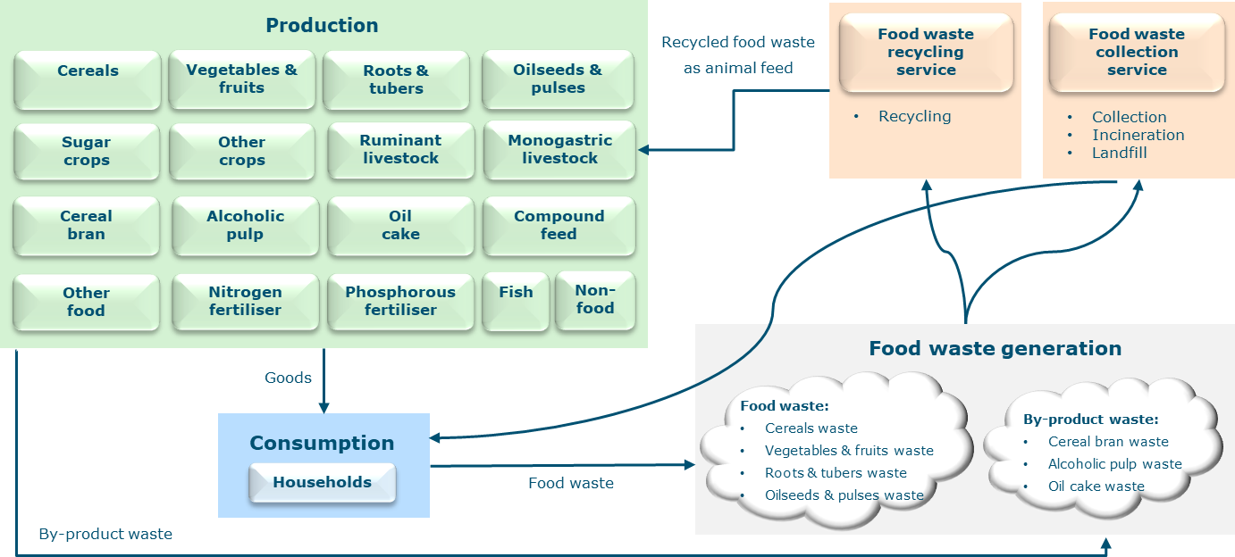

**Fig. 1 | Representation of the economy in China in an AGE framework with the module of food waste treatment.** The generated food waste is sent either to the ‘food waste recycling service’ sector or the ‘food waste collection service’ sector. The food waste recycling service sector produces food waste recycling services to recycle food waste as feed for monogastric livestock production. The food waste collection service sector produces food waste collection services to collect food waste for landfill and incineration. The consumer price of food includes both the market price of food and the cost of collecting food waste by the municipality. In terms of recycling food waste as feed, monogastric livestock production bears the associated cost. Detailed information is presented in Methods and Supplementary Information.

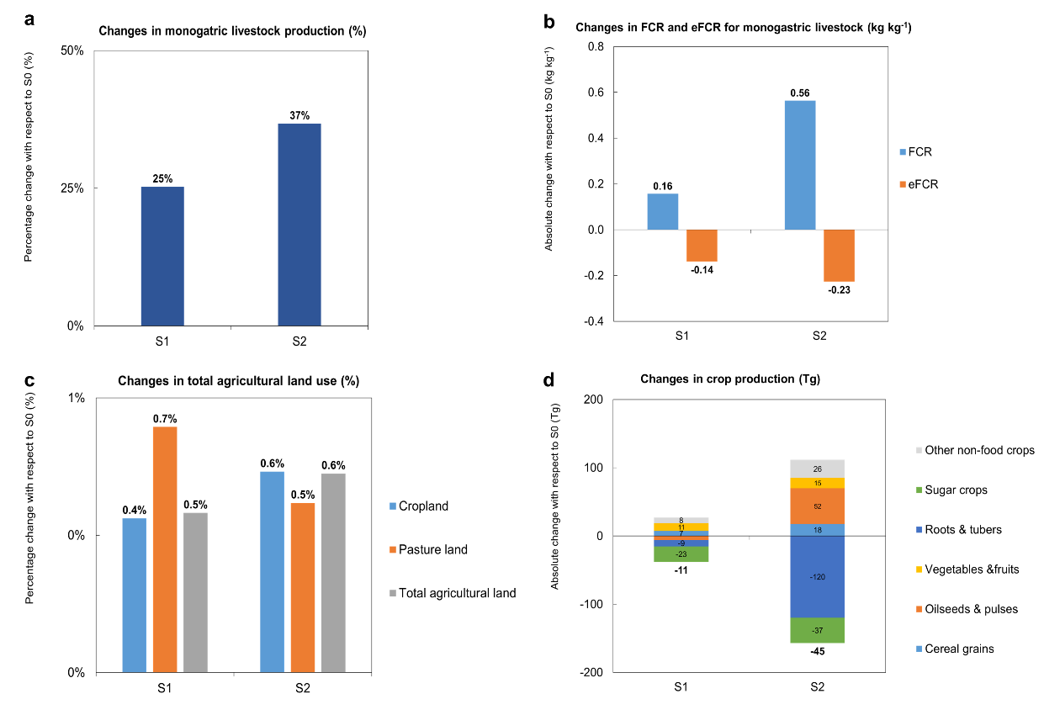

**Fig. 2 | Impacts of upcycling food waste in monogastric livestock as feed on domestic livestock and crop production in China.** (**a**) Percentage changes (%) in monogastric livestock production in scenarios with respect to S0. (**b**) Absolute changes (kg kg-1) in feed conversion ratio (FCR) and edible feed conversion ratio (eFCR) for monogastric livestock in scenarios with respect to S0. (**c**) Percentage shares (%) for cropland and pasture land occupation with respect to S0. (**d**) Absolute changes (Tg) in crop production in scenarios with respect to S0. Definitions of scenarios (S1- ‘Allowing partial use of food waste as feed’; S2- ‘Allowing full use of food waste as feed with economies of scale’) are described in Table 1.

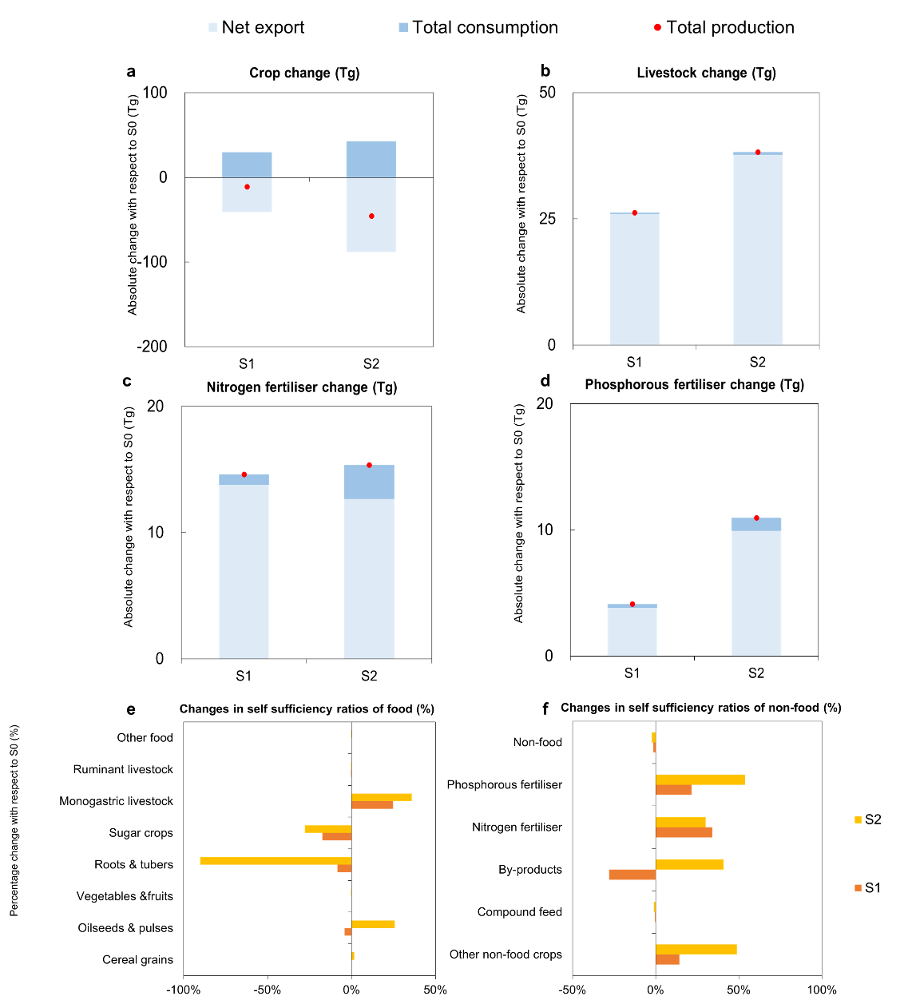

**Fig. 3 | Impacts of upcycling food waste in monogastric livestock as feed on domestic production, consumption, and trade of food and non-food in China. a–d,** absolute changes (Tg) in China’s (**a**) crop consumption, production, and net exports, (**b**) livestock consumption, production, and net exports, (**c**) nitrogen fertiliser consumption, production, and net exports, and (**d**) phosphorous fertiliser consumption, production, and net exports in scenarios with respect to S0 in China. **d–e,** percentage changes (%) in self-sufficiency ratios (SSRs) of (**d**) food and (**e**) non-food. Definitions of scenarios (S1- ‘Allowing partial use of food waste as feed’; S2- ‘Allowing full use of food waste as feed with economies of scale’) are described in Table 1.

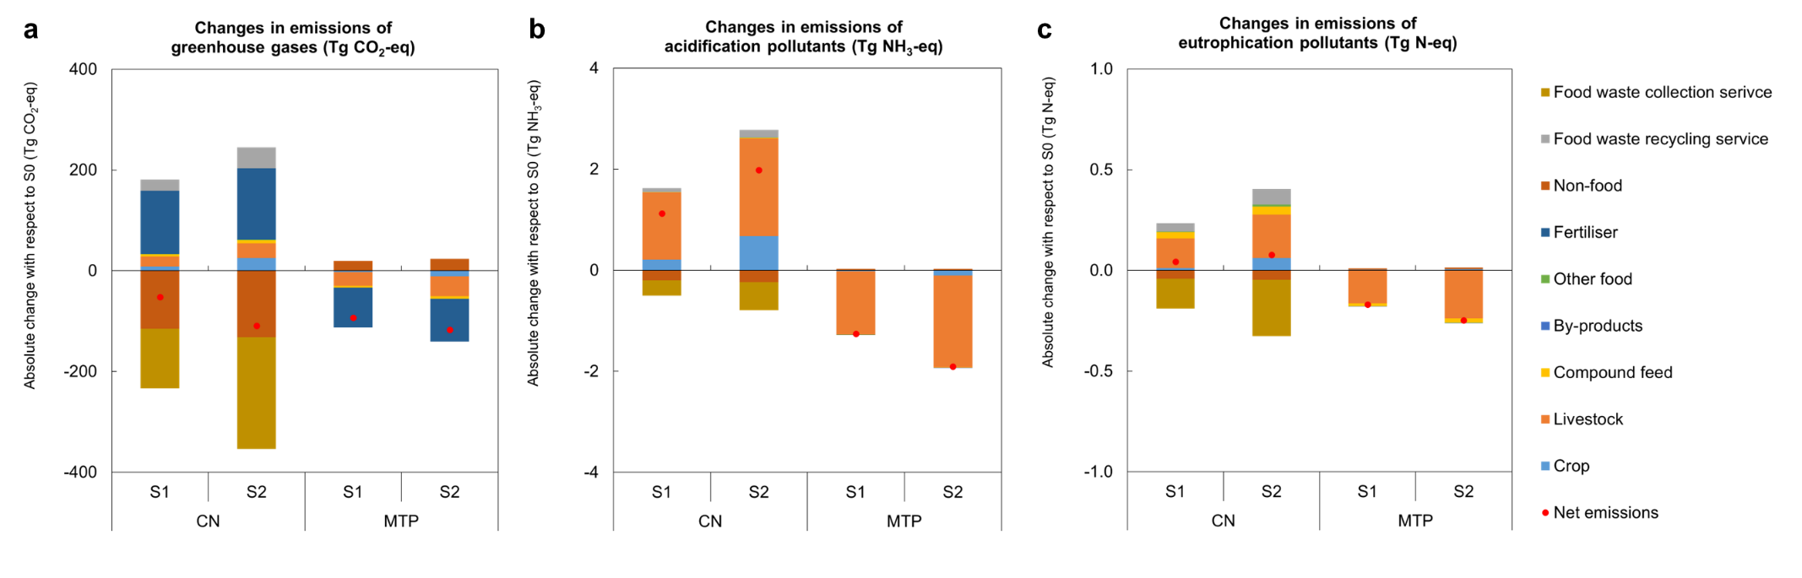

**Fig. 4 | Impacts of upcycling food waste in monogastric livestock as feed on emissions in China (CN) and China’s main food and feed trading partners (MTP).** Absolute changes in (**a**) emissions of greenhouse gases (Tg CO2-eq), (**b**) acidification pollutants (Tg NH3-eq), and (**c**) eutrophication pollutants (Tg N-eq) in scenarios with respect to S0. Here, MTP includes Brazil, the United States, and Canada. Definitions of scenarios (S1- ‘Allowing partial use of food waste as feed’; S2- ‘Allowing full use of food waste as feed with economies of scale’) are described in Table 1.

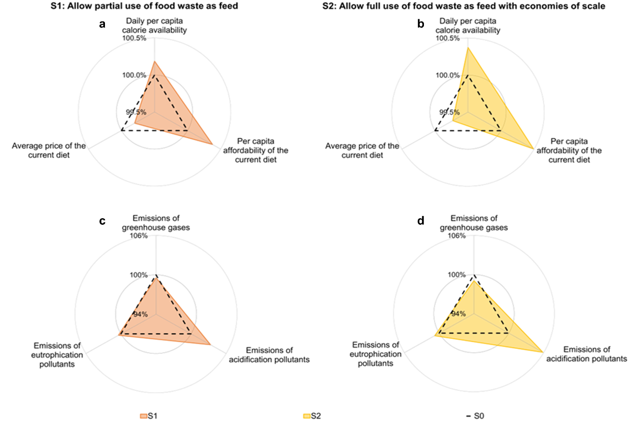

**Fig. 5 | Impacts of upcycling food waste in monogastric livestock as feed on domestic sustainability in China.** Percentage changes (%) of food security-related (i.e., daily per capita calorie availability, per capita affordability, and average price of the current diet) and environment sustainability-related (emissions of greenhouse gases, acidification pollutants, and eutrophication pollutants) indicators in (**a, c**) scenario S1 and (**b, d**) scenario S2 with respect to S0. Definitions of scenarios (S1- ‘Allowing partial use of food waste as feed’; S2- ‘Allowing full use of food waste as feed with economies of scale’) are described in Table 1.

**Table 1 |** Summary of key assumptions used in the quantification of feed use in scenarios S0, S1, and S2 in China.

|  |  |  |
| --- | --- | --- |
| **Scenarios a** | **Food waste as animal feed in its total supply b** | **Detailed explanation c** |
| **S0: Baseline** | Food waste: 39%  By-products: 51% |  |
| **S1: Allowing partial use of food waste as feed** | Food waste: 54%  By-products: 100% | Increasing the supply of food waste recycling service and decreasing the supply of food waste collection service to achieve 54% of food waste and 100% by-product waste being recycled as feed for monogastric livestock production. |
| **S2: Allowing full use of food waste as feed with economies of scale** | Food waste: 100%  By-products: 100% | Increasing the supply of food waste recycling service and decreasing the supply of food waste collection service to achieve 100% of food waste and 100% by-product waste being recycled as feed for monogastric livestock production. |

a When substituting primary feed (i.e., crops and compound feed) in animal diets with food waste, we maintain the protein and energy supply per unit of animal output in all scenarios to prevent imbalances between nutritional (protein and energy) supply and livestock requirements.

b In S1, cross-provincial transportation of food waste with high moisture content was not allowed, which limits the maximum utilisation rate of food waste to 54% in China, according to Fang, et al. 10, whereas it was allowed in S2.

c We increase the supply of food waste recycling service by exogenously raising the cost of recycling food waste as feed (54 dollar ton-1) and decrease the supply of food waste recycling service by exogenously lowering the cost of collecting food waste for landfill and incineration (82 dollar ton-1). Detailed information regarding the cost calculation is provided in Supplementary Table A4. Economies of scale in food waste recycling were considered in S2, where a 1% increase in recycled waste resulted in only a 0.078% rise in recycling costs, indicating that increasing the amount of recycled waste might not necessarily incur additional costs, as reported by Cialani and Mortazavi 31. This is because, initially, recycling entails high fixed costs, yet as production scales up, marginal costs decrease and stabilise.